**Passenger Van Cargo Barrier Instructions**

## Assembly Instructions

1. Place 2 6" Velcro strips on the bottom of the base hoop.
2. Thread two large nuts on each side of the threaded ends of the base hoop. Slide the threaded ends of the base support hoop into the uprights attached to the screen.
3. Place two Velcro strips on top of the top supports.
4. Place the top supports into the uprights.

## Final Assembly Location

1. Place the barrier behind the first or second row of seats as shown.
2. Tighten the top nuts until the barrier will no longer move.
3. Tighten the bottom nuts against the top nuts to lock into place.
4. Now tighten the four bolts attaching the screen.
5. 0

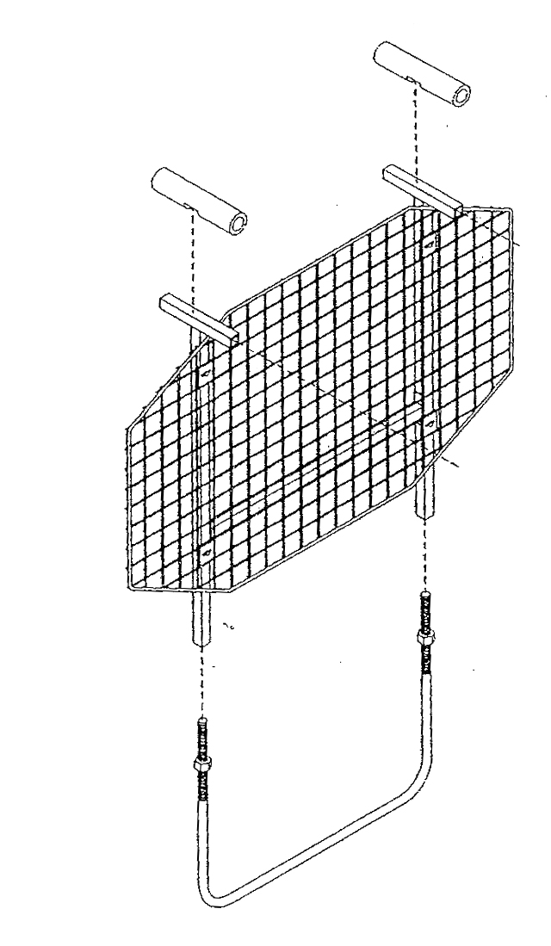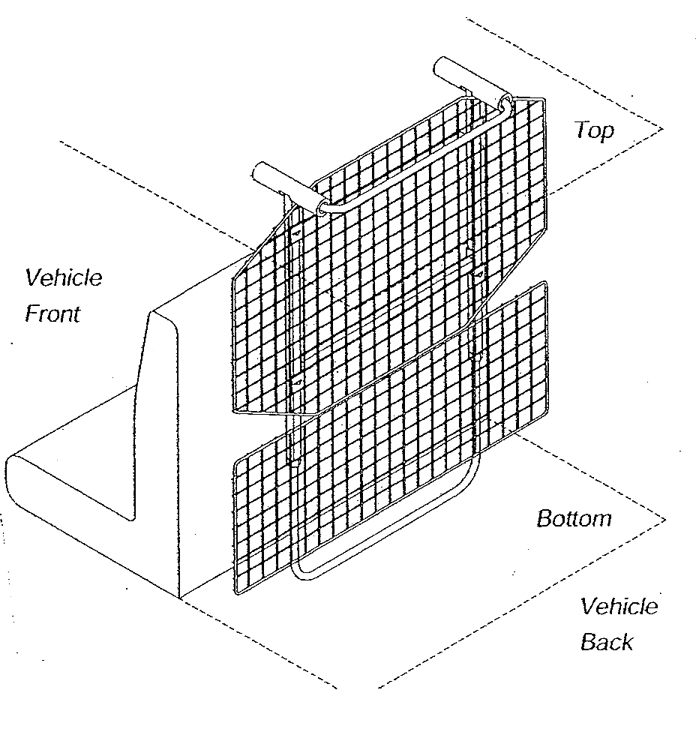

## Optional Lower Screen

1. After placing the barrier into the vehicle, attach 2 Zip-Ties to the bottom of the upper screen.
2. Place the remaining Zip-Ties around the lower screen and bottom support loop.

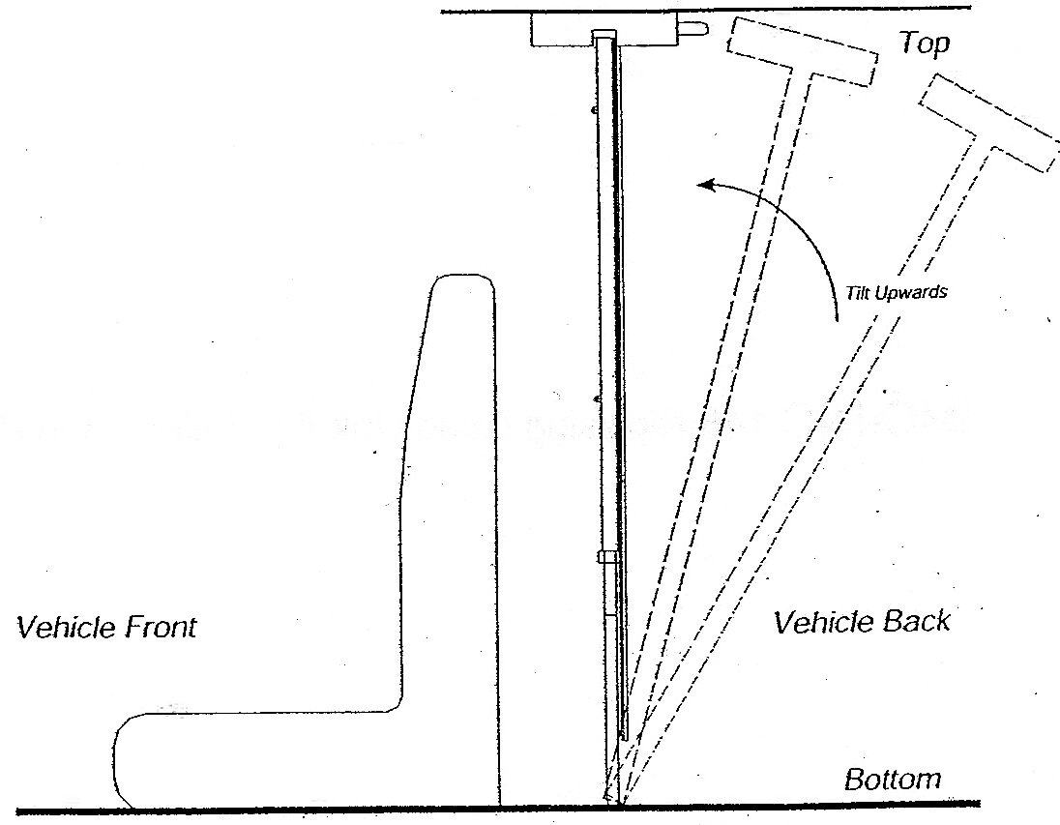

*Note: Do not worry about over tightening nuts, it will not damage the unit*

## Maintenance Procedure

It is recommended that if the barrier is not removed on a regular basis that you periodically check to ensure it is supported with the proper amount of pressure. Please follow the steps below.

1. Securely grip the barrier and give it a firm shake. If the barrier has any movement see step 2.
2. Using the 7/8 wrench, tighten the top two base nuts until the barrier no longer has any movement. Then tighten the lower two nuts against the upper nuts.